**Creating Microservices for account and loan**

**Account Microservice :-**

**AccountServiceApplication.java :-**

package com.cognizant.account;  
  
  
import org.springframework.boot.SpringApplication;  
import org.springframework.boot.autoconfigure.SpringBootApplication;  
  
@SpringBootApplication  
public class AccountServiceApplication {  
 public static void main(String[] args) {  
 SpringApplication.*run*(AccountServiceApplication.class, args);  
 }  
}

**AccountController.java :-**

package com.cognizant.account.controller;  
  
  
  
import org.springframework.web.bind.annotation.*;  
  
import java.util.Map;  
  
@RestController  
@RequestMapping("/accounts")  
public class AccountController {  
  
 @GetMapping("/{number}")  
 public Map<String, Object> getAccountDetails(@PathVariable String number) {  
 return Map.*of*(  
 "number", number,  
 "type", "savings",  
 "balance", 234343  
 );  
 }  
}

**application.properties :-**

spring.application.name=account  
server.port=8081

**pom.xml :-**

<?xml version="1.0" encoding="UTF-8"?>  
<project xmlns="http://maven.apache.org/POM/4.0.0" xmlns:xsi="http://www.w3.org/2001/XMLSchema-instance"  
 xsi:schemaLocation="http://maven.apache.org/POM/4.0.0 https://maven.apache.org/xsd/maven-4.0.0.xsd">  
 <modelVersion>4.0.0</modelVersion>  
 <parent>  
 <groupId>org.springframework.boot</groupId>  
 <artifactId>spring-boot-starter-parent</artifactId>  
 <version>3.5.3</version>  
 <relativePath/> <!-- lookup parent from repository -->  
 </parent>  
 <groupId>com.cognizant</groupId>  
 <artifactId>account</artifactId>  
 <version>0.0.1-SNAPSHOT</version>  
 <name>account</name>  
 <description>Demo project for Spring Boot</description>  
 <url/>  
 <licenses>  
 <license/>  
 </licenses>  
 <developers>  
 <developer/>  
 </developers>  
 <scm>  
 <connection/>  
 <developerConnection/>  
 <tag/>  
 <url/>  
 </scm>  
 <properties>  
 <java.version>21</java.version>  
 </properties>  
 <dependencies>  
 <dependency>  
 <groupId>org.springframework.boot</groupId>  
 <artifactId>spring-boot-starter-web</artifactId>  
 </dependency>  
  
 <dependency>  
 <groupId>org.springframework.boot</groupId>  
 <artifactId>spring-boot-devtools</artifactId>  
 <scope>runtime</scope>  
 <optional>true</optional>  
 </dependency>  
 <dependency>  
 <groupId>org.springframework.boot</groupId>  
 <artifactId>spring-boot-starter-test</artifactId>  
 <scope>test</scope>  
 </dependency>  
 </dependencies>  
  
 <build>  
 <plugins>  
 <plugin>  
 <groupId>org.springframework.boot</groupId>  
 <artifactId>spring-boot-maven-plugin</artifactId>  
 </plugin>  
 </plugins>  
 </build>  
  
</project>

Output :-

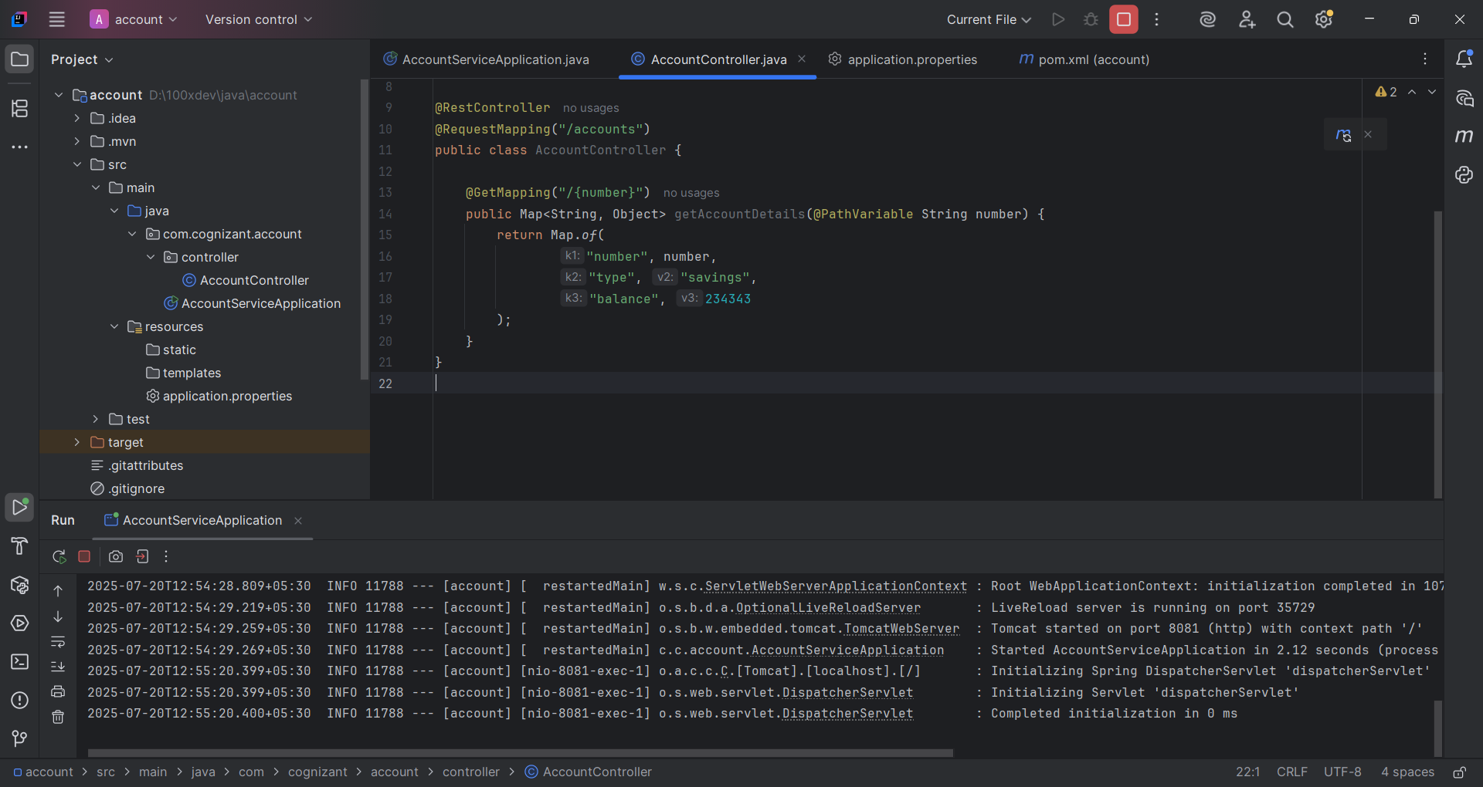

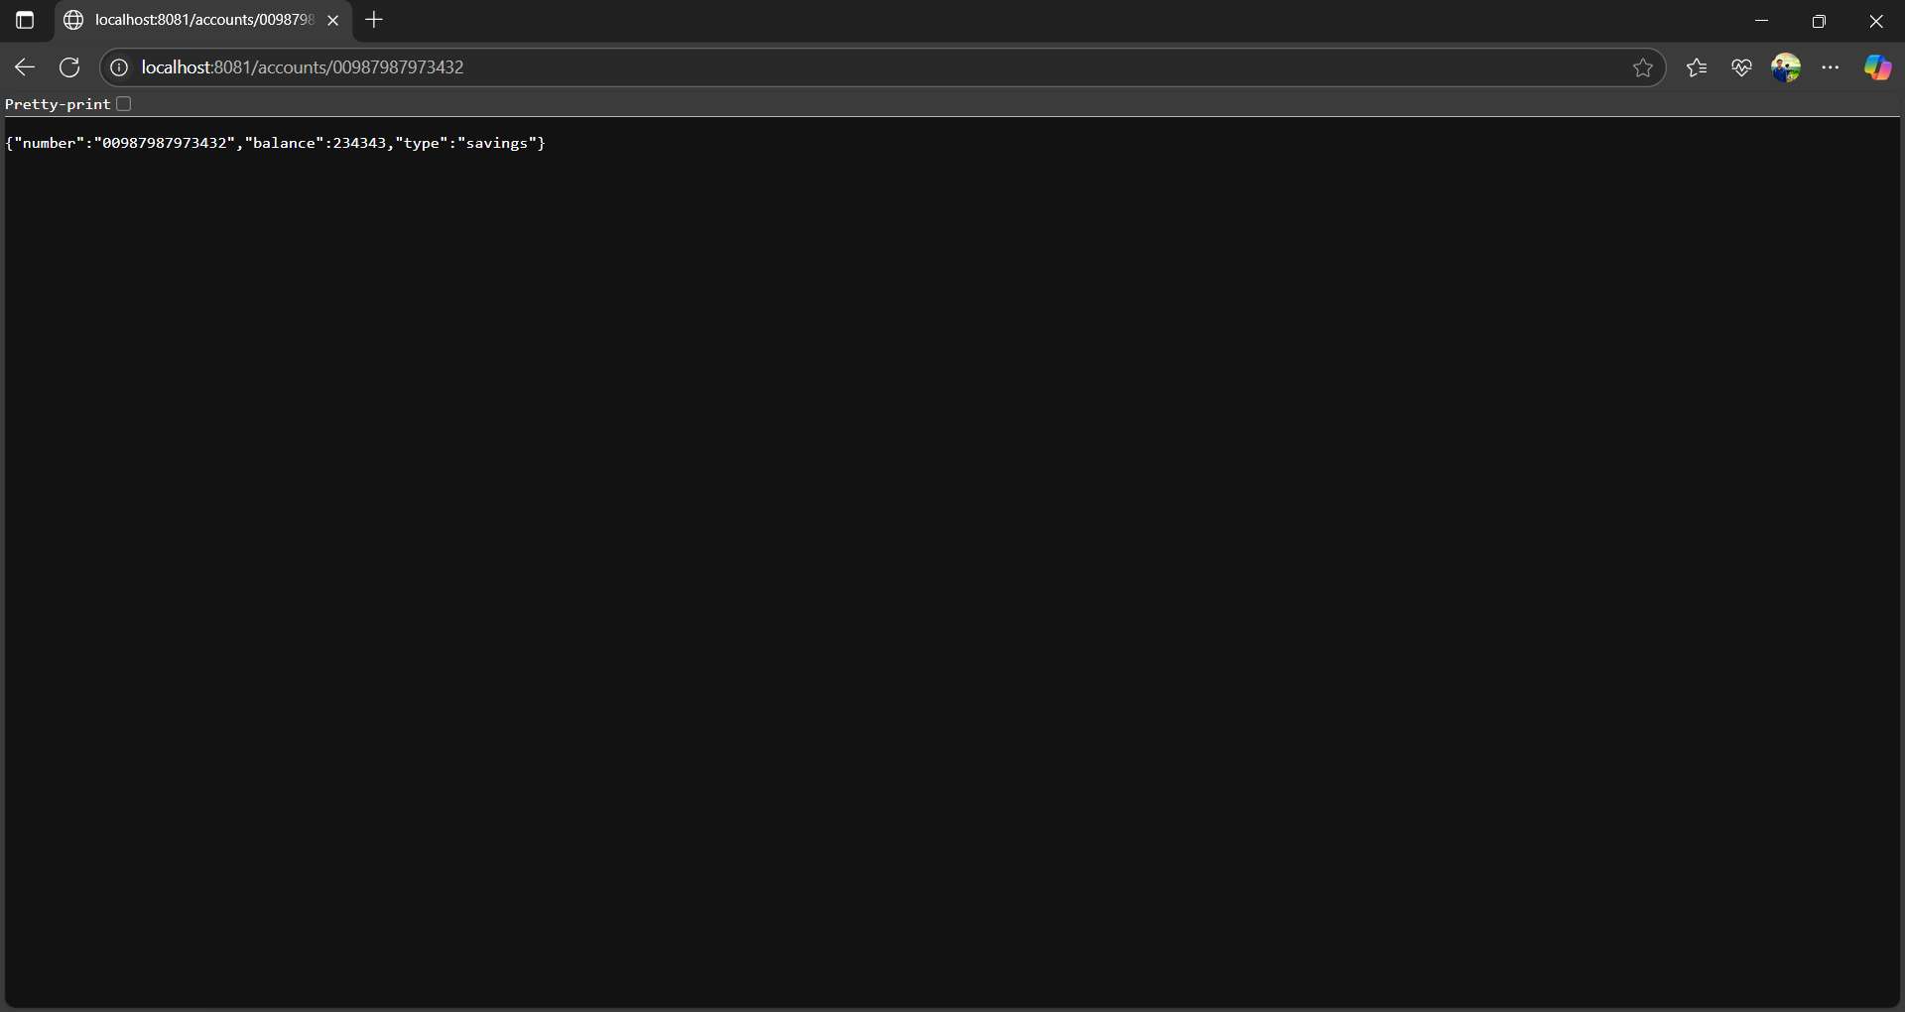

**Loan Microservice :-**

**LoanServiceApplication.java :-**

package com.cognizant.loan;  
  
import org.springframework.boot.SpringApplication;  
import org.springframework.boot.autoconfigure.SpringBootApplication;  
  
@SpringBootApplication  
public class LoanServiceApplication {  
 public static void main(String[] args) {  
 SpringApplication.*run*(LoanServiceApplication.class, args);  
 }  
}

**LoanController.java :-**

package com.cognizant.loan.controller;  
  
import org.springframework.web.bind.annotation.*;  
  
import java.util.Map;  
  
@RestController  
@RequestMapping("/loans")  
public class LoanController {  
  
 @GetMapping("/{number}")  
 public Map<String, Object> getLoanDetails(@PathVariable String number) {  
 return Map.*of*(  
 "number", number,  
 "type", "car",  
 "loan", 400000,  
 "emi", 3258,  
 "tenure", 18  
 );  
 }  
}

**application.properties :-**

spring.application.name=account  
server.port=8090

**pom.xml :-**

<?xml version="1.0" encoding="UTF-8"?>  
<project xmlns="http://maven.apache.org/POM/4.0.0" xmlns:xsi="http://www.w3.org/2001/XMLSchema-instance"  
 xsi:schemaLocation="http://maven.apache.org/POM/4.0.0 https://maven.apache.org/xsd/maven-4.0.0.xsd">  
 <modelVersion>4.0.0</modelVersion>  
 <parent>  
 <groupId>org.springframework.boot</groupId>  
 <artifactId>spring-boot-starter-parent</artifactId>  
 <version>3.5.3</version>  
 <relativePath/> <!-- lookup parent from repository -->  
 </parent>  
 <groupId>com.cognizant</groupId>  
 <artifactId>loan</artifactId>  
 <version>0.0.1-SNAPSHOT</version>  
 <name>loan</name>  
 <description>Demo project for Spring Boot</description>  
 <url/>  
 <licenses>  
 <license/>  
 </licenses>  
 <developers>  
 <developer/>  
 </developers>  
 <scm>  
 <connection/>  
 <developerConnection/>  
 <tag/>  
 <url/>  
 </scm>  
 <properties>  
 <java.version>21</java.version>  
 </properties>  
 <dependencies>  
 <dependency>  
 <groupId>org.springframework.boot</groupId>  
 <artifactId>spring-boot-starter-web</artifactId>  
 </dependency>  
  
 <dependency>  
 <groupId>org.springframework.boot</groupId>  
 <artifactId>spring-boot-devtools</artifactId>  
 <scope>runtime</scope>  
 <optional>true</optional>  
 </dependency>  
 <dependency>  
 <groupId>org.springframework.boot</groupId>  
 <artifactId>spring-boot-starter-test</artifactId>  
 <scope>test</scope>  
 </dependency>  
 </dependencies>  
  
 <build>  
 <plugins>  
 <plugin>  
 <groupId>org.springframework.boot</groupId>  
 <artifactId>spring-boot-maven-plugin</artifactId>  
 </plugin>  
 </plugins>  
 </build>  
  
</project>

Output :-

